Name: _______________________ Class: __________ Date: _______
Instructions: Write answers in the right-hand column. Score: ___________ / 32 marks

Section A—Multiple choice (5 marks)

 | The following equation represents the decomposition of lead(II) nitrate on heating  x Pb(NO₃)₂ → y PbO + z NO₂ + O₂  The respective values of x, y and z are:  A 1, 2, 2  B 2, 2, 4  C 4, 4, 8  D 2, 3, 4 | B | 1
 | Which of these is an incorrect interpretation of this balanced equation?  2S(s) + 3O₂(g) → 2SO₃(g)  A 2 atoms S + 3 molecules O₂ → 2 molecules SO₃  B 2 g S + 3 g O₂ → 2 g SO₃  C 2 mol S + 3 mol O₂ → 2 mol SO₃  D none of the above. | B | 1
 | 54 g of hydrogen cyanide, HCN, combined with 80 g of oxygen to produce 18 g of water, 28 g of nitrogen and carbon dioxide, but nothing else. The carbon dioxide had a mass of:  A 44 g  B 88 g  C 134 g  D 286 g | B | 1
 | When one mole of a particular compound containing only carbon and hydrogen is burnt in excess pure oxygen, equal amounts, in mole, of CO₂ and H₂O are formed. The hydrocarbon could be:  A CH₄  B C₂H₆  C C₂H₄  D C₆H₆ | C | 1
 | A solution of sodium hydroxide when added to a solution of aluminium chloride produces a gel-like precipitate. The precipitate reaction could be represented as:  A Na⁺(aq) + Cl–(aq) → NaCl(s)  B Al³⁺(aq) + 3OH–(aq) → Al(OH)₃(s)  C Al³⁺(aq) + 3Cl–(aq) → AlCl₃(s)  D H⁺(aq) + OH–(aq) → H₂O(l) | B | 1

Section B—Written answers (27 marks)

 | Write balanced molecular equations for each of the following reactions:  a aluminium is heated with steam to give hydrogen gas and solid aluminium oxide  b chlorine gas is bubbled through a solution of sodium iodide to form solid iodine and a solution of sodium chloride  c solid manganese(IV) oxide (MnO₂) is added to dilute hydrochloric acid to produce water, chlorine gas and a solution of manganese(II) chloride  d solutions of calcium hydroxide and phosphoric acid are mixed to give a precipitate of calcium phosphate, and water  e copper(II) oxide reacts with ammonia gas to produce copper, nitrogen gas and water. | a 2Al(s) + 3H₂O(g) → Al₂O₃(s) + 3H₂(g)  b Cl₂(g) + 2NaI(aq) → I₂(s) + 2NaCl(aq)  c MnO₂(s) + 4HCl(aq)  → Cl₂(g) + 2H₂O(l) + MnCl₂(aq)  d 3Ca(OH)₂(aq) + 2H₃PO₄(aq)  → Ca₃(PO₄)₂(s) + 6H₂O(l)  e 3CuO(s) + 2NH₃(g)  → 3Cu(s) + N₂(g) + 3H₂O(l) | 5
 | When butane is burnt in air, the following reaction occurs:  2C₄H₁₀(g) + 13O₂(g)  → 8CO₂(g) + 10H₂O(g)  What mass of carbon dioxide would be formed from the burning of 143 g of butane in excess oxygen? | n(butane) = 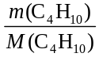  = = 2.460 mol  From equation,  2 mol C₄H₁₀ produces 8 mol CO₂,  so 1 mol C₄H₁₀ produces 4 mol CO₂.  n(CO₂) formed = 4 × 2.460  = 9.840 mol  mass (CO₂) formed = n × M  = 9.840 × 44.01  = 433 g | 4
 | What is the concentration, in mol L^{–1}, of a K₂C₂O₄ solution if 35.00 mL of it is required to react completely with 47.65 mL of 0.0632 mol L^{–1} KMnO₄ solution?  2MnO₄–(aq) + 5C₂O₄^{2–}(aq) + 16H⁺(aq) → 2Mn²⁺(aq) + 10CO₂(g) + 8H₂O(l) |  | 4
 | n(KMnO₄) = cV = 0.0632 × 0.04765  = 0.003011 mol = mol of MnO₄–  From equation, 2 mol of MnO₄– reacts completely with 5 mol of C₂O₄^{2–}  so 1 mol of MnO₄– reacts completely with mol of C₂O₄^{2–}  therefore 0.003011 mol of MnO₄– reacts completely with × 0.003011  = 0.007528 mol of C₂O₄^{2–}  That is, mol of K₂C₂O₄ required = 0.007528  c(K₂C₂O₄) = 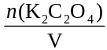 =  = 0.215 mol L^{–1} |  | 4
9 | Evil smelling hydrogen sulfide (bad-egg gas), H₂S, can be destroyed by reacting it with oxygen according to the equation:  2H₂S(g) + 3O₂(g) → 2SO₂(g) + 2H₂O(l)  What mass of oxygen will be left over when 16.0 g of hydrogen sulfide reacts with 30.0 g of oxygen? | 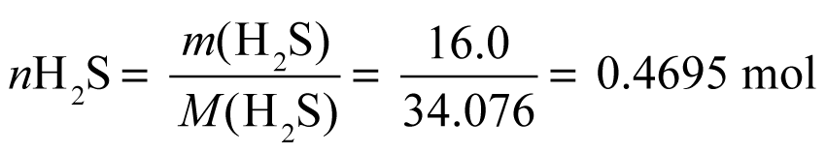  From equation,  2 mol H₂S combines with 3 mol O₂  so 1 mol H₂S combines with mol O₂  0.4695 mol of H₂S reacts with 0.7042 mol O₂  m(O₂) = n(O₂) × M(O₂)  = 0.7042 × 32.00 = 22.53 g  Mass of O₂ remaining is 30.0 - 22.53  = 7.47 g | 4
10 | What is the concentration, in g L^{–1}, of a solution of hydrochloric acid if 30.0 mL of this solution reacted completely with 40.0 mL of 0.244 mol L^{–1} NaOH?  H⁺(aq) + OH–(aq) → H₂O | n(NaOH) = cV = 0.244 × 0.0400  = 0.009760 mol  = n(OH–)  From equation, n(H⁺) = n(OH–)  = 0.009760  = n(HCl)  n(HCl) = 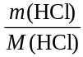  m(HCl) = 0.009760 × 36.458  = 0.3558 g  c(HCl) = 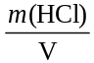  = = 11.9 g L^{–1} | 4
11 | A liquid sweetener contains the artificial sweetener calcium saccharin. The negative ion of saccharin is shown below:  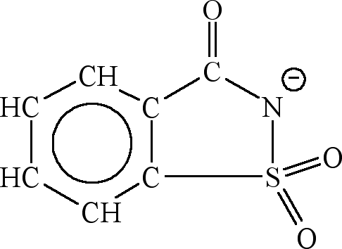  To determine the percentage, by mass, of calcium saccharin in the liquid sweetener, 52.4 g of the liquid sweetener was reacted with a strong oxidising agent to convert all the sulfur present in the saccharin ions to sulfate ions. A solution of barium chloride was then added to form an insoluble solid called barium sulfate, from all the sulfate ions. The insoluble barium sulfate solid was filtered from the mixture, dried and weighed. Its mass was 1.27 g:  a What is the formula of calcium saccharin?  b How many mole of barium sulfate was formed from the liquid sweetener?  c How many mole of sulfur atoms are contained in this amount of barium sulfate?  d Assuming all the sulfur atoms in the barium sulfate were originally present in the calcium saccharin, calculate the mass of calcium saccharin in the 52.4 g sample of the liquid sweetener.  e What is the percentage, by mass, of calcium saccharin in the liquid sweetener? | a Ca(C₇H₄NO₃S)₂  b n(BaSO₄) = 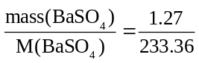  = 0.00544 mol  c n(S) = n(BaSO₄) = 0.00544 mol  d 2 mol of S is contained in 1 mol of  calcium saccharin  or 1 mol of S is contained in ½ mol of  calcium saccharin  n(calcium saccharin) = ½ × n(S)  = 0.00272 mol  m(calcium saccharin) = n × M  = 0.00272 × 404.424  = 1.10 g  e Percentage of calcium saccharin  = 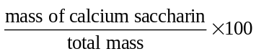  = 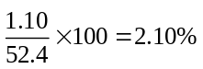 | 6

